2)Create 3 tablespaces

2.1) First one with 3Gb and 1 datafile, the name of the tablespace should be "coordinadora"

2.2) Undo tablespace with 100Mb and 1 datafile (Set this tablespace to be used in the system)

2.3) Bigfile tablespace of 4Gb

solution

**2.1) se crea el tablespace con 3G y con un data file llamado DatFileCoordinadora**

create tablespace coordinadora datafile 'DatFileCoordinadora' size 3000M;

**listar los tablespaces creados**

select TABLESPACE_NAME from SYS.DBA_TABLESPACES;

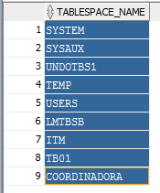

**listar los datafiles creados**

select TABLESPACE_NAME, BYTES,ONLINE_STATUS from SYS.DBA_DATA_FILES;

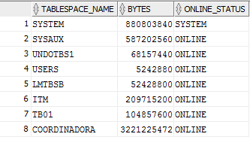

2.2) Undo tablespace with 100Mb and 1 datafile (Set this tablespace to be used in the system)

create UNDO TABLESPACE undotscoordinadora

DATAFILE 'undotbsCoord.dbf'

SIZE 100M;

**listar los tablespaces creados**

select TABLESPACE_NAME from SYS.DBA_TABLESPACES;

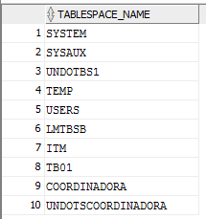

**listar los datafiles creados**

select TABLESPACE_NAME, BYTES, ONLINE_STATUS from SYS.DBA_DATA_FILES;

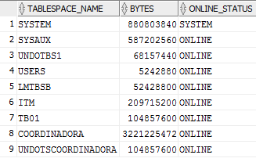

**2.3) Bigfile tablespace of 4Gb**

create BIGFILE TABLESPACE bigtbs_Coordinadora

DATAFILE 'bigtbCoord_f1.dbf'

SIZE 4000M;

**listar los tablespaces creados**

select TABLESPACE_NAME from SYS.DBA_TABLESPACES;

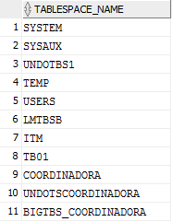

**listar los datafiles creados**

select TABLESPACE_NAME, BYTES, ONLINE_STATUS from SYS.DBA_DATA_FILES;

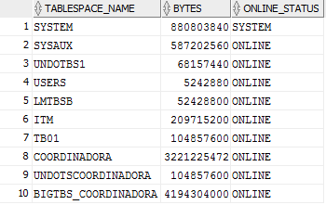

1. Create an user with the username amartinezg.
   * The user should be assigned to the tablespace.
   * There are no restrictions of space for this user.
   * The role of the user should be dba
   * The user should be able to connect to the system.

**Solution**

**CODE:**

CREATE USER amartinezg

IDENTIFIED BY amartinezg

DEFAULT TABLESPACE COORDINADORA

QUOTA UNLIMITED ON COORDINADORA;

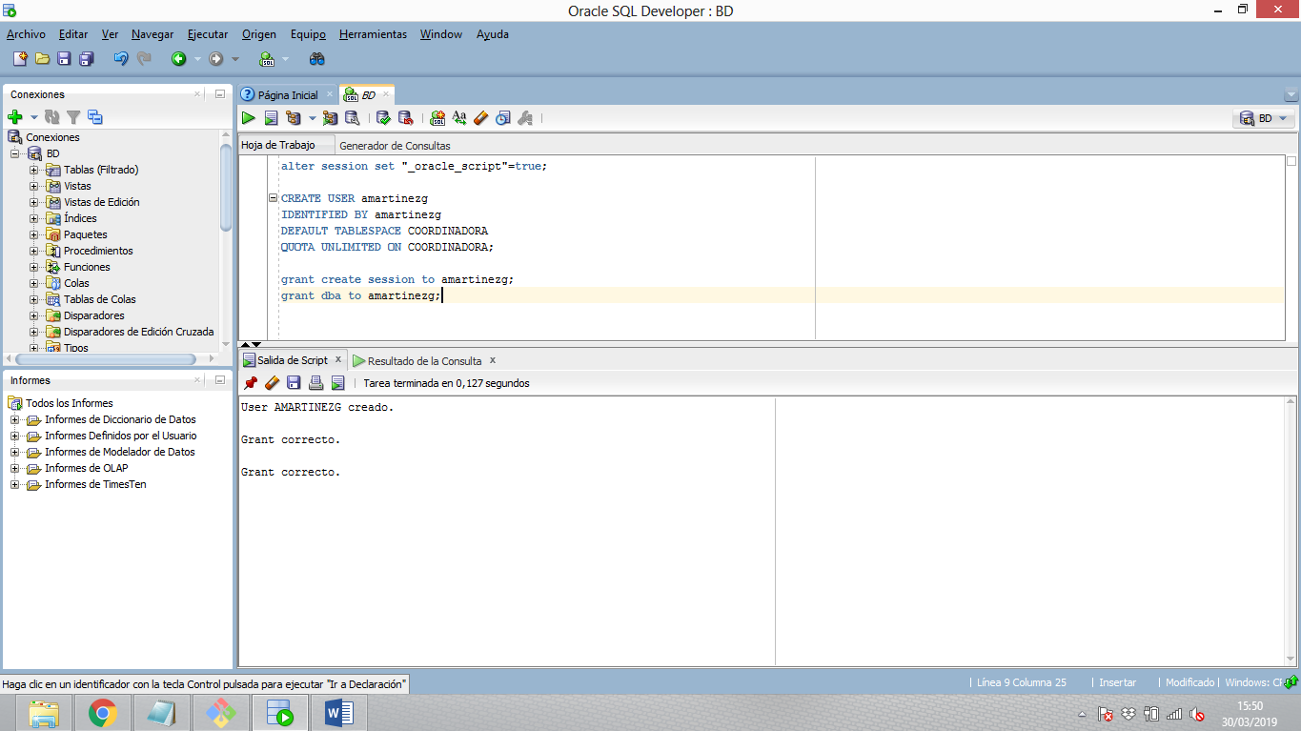

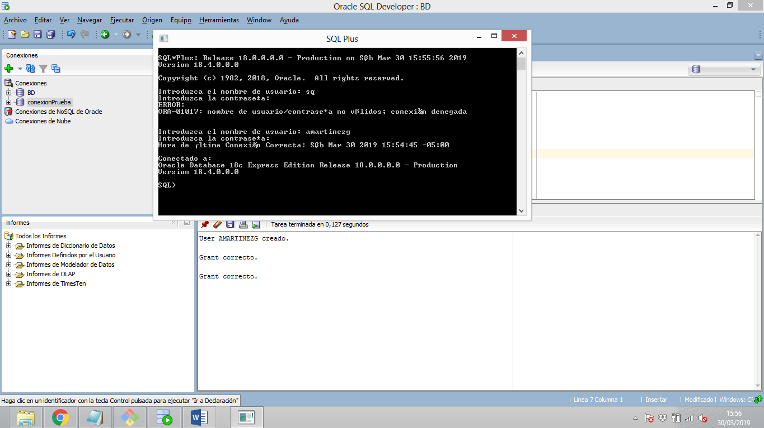

Create 3 profiles:

1. Profile 1: **clerk** with a password life of 40 days, one session per user, 15 minutes of idle, 3 failed login attempts.
2. Profile 2: **development** with a password life of 100 days, two sessions per user, 30 minutes of idle and no failed login attempts.
3. Profile 3: **operative** with a password life of 30 days, one session per user, 5 minutes of idle, 4 failed login attemps. This profile can reuse the password after 30 days if the password has already been changed 3 times.

**Profile 1: clerk**

CREATE PROFILE CLERK LIMIT

SESSIONS_PER_USER 1

IDLE_TIME 15

FAILED_LOGIN_ATTEMPTS 3

PASSWORD_LIFE_TIME 40;

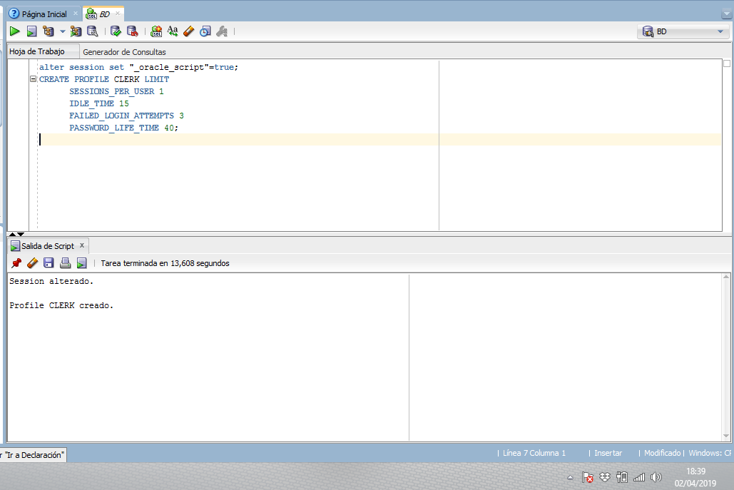

**Profile 2: development**

CREATE PROFILE DEVELOPMENT LIMIT

SESSIONS_PER_USER 2

IDLE_TIME 30

FAILED_LOGIN_ATTEMPTS 1

PASSWORD_LIFE_TIME 100;

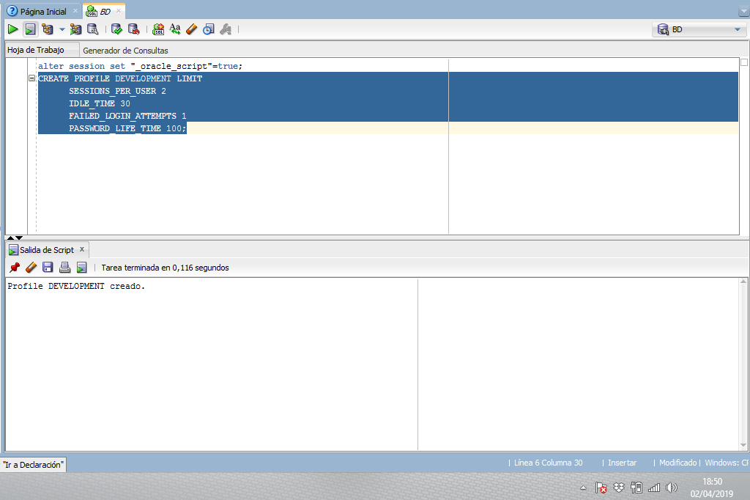

**Profile 3: operative**

CREATE PROFILE OPERATIVE LIMIT

SESSIONS_PER_USER 1

IDLE_TIME 5

FAILED_LOGIN_ATTEMPTS 4

PASSWORD_LIFE_TIME 30

PASSWORD_REUSE_MAX 3

PASSWORD_REUSE_TIME 30;

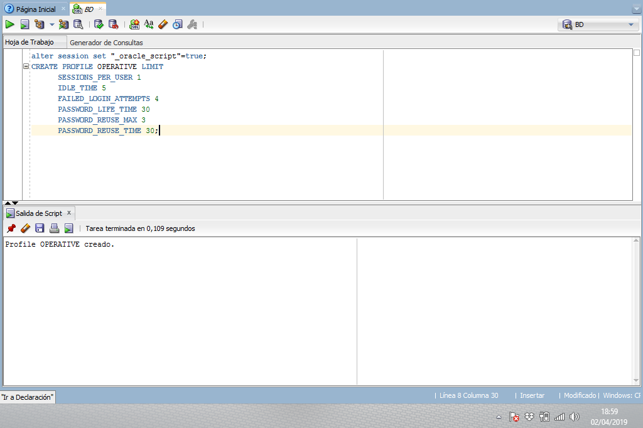

Create 3 users:

* You are free to pick the username
* One user should user the profile **clerk**, the second one **development** and the last one **operative**
* All of them should be able to connect to the database.
* The user with the profile **operative** should be locked.